1. The Church-Turing Thesis states that any computable function performed on natural numbers can be translated into an equivalent computation if and only if it is computable by a Turing Machine. While the Church-Turing Thesis has yet to be disproven, we are currently unsure if it will stand the test of time as our knowledge of the universe grows. There is no designated mathematical proof which shows that the given method logically guarantees the intended outcome of the thesis. So, in short, there’s no formal proof the thesis works but we have yet to disprove that it doesn’t work.
2. SCHEMA  
   A piece of paper with writing on it

   Description automatically generated
3. A Turing Machine with a single two-dimensional tape which is infinite in all directions functions like an ordinary Turing Machine except that the input tape given is a two-dimensional array of cells instead of a one-dimensional array given in normal TMs. For the two-dimensional tape, each cell has an address given in the form: (i, j) where both i and j map to the cells on the two-dimensional tape. Since the tape is infinite in all directions, the tape will extend in all directions infinitely (i, j). Turing machines with infinitely extending tapes are only as powerful as TMs with a finite ending to a side as we are always given a one finite control. The two-dimensional TM also has a single head which reads the contents of the cell which it is currently visiting and decides on what to do based on the cell and its state. The head can write on the tape cell, move up, move down, move right, or move left. This is proof that an ordinary TM can simulate the functions of a given two-dimensional TM. A piece of paper with writing on it

   Description automatically generated
4. When comparing a 2022 computer from an electronics store with the Universal TM we assume that our purchased computer has a limited number of resources such as memory. A computer’s physical aspect makes it inferior to the conceptual model of the UTM which can calculate anything that is calculatable. When compared to the UTM which theoretically has infinite resources granting it the ability to accept far more languages than a computer in our time would ever.   
   Adding a graphics processing card to the computer would not change our answer as the GPU would not fundamentally change what is possible with the computer and will only do what was previously done better/faster. The finite physical limitations are also still present even though a GPU was installed.
5. On paper  
    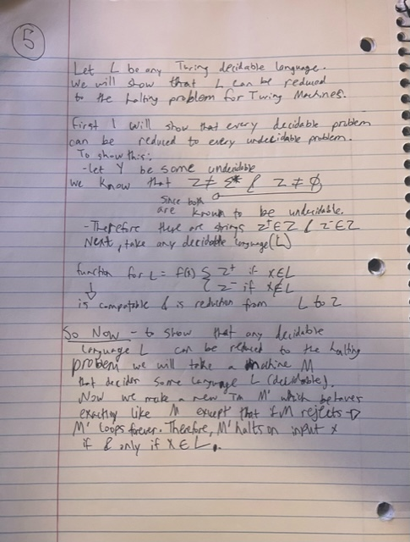
6. A)  
   Text, letter

   Description automatically generated  
   Text, letter

   Description automatically generated  
     
   B)   
   A piece of paper with writing

   Description automatically generated with medium confidence